Lab: CI/CD to Azure Web App (Container) for a Node.js App (GitHub Actions)

What you’ll build?
A GitHub Actions pipeline that:
- installs & tests a Node.js app
- builds a Docker image
- pushes the image to Docker Hub
- deploys that image to an Azure Web App for Containers

At a glance (flow)
GitHub → Actions (build & test) → Docker image → Docker Hub → Azure Web App (Container)

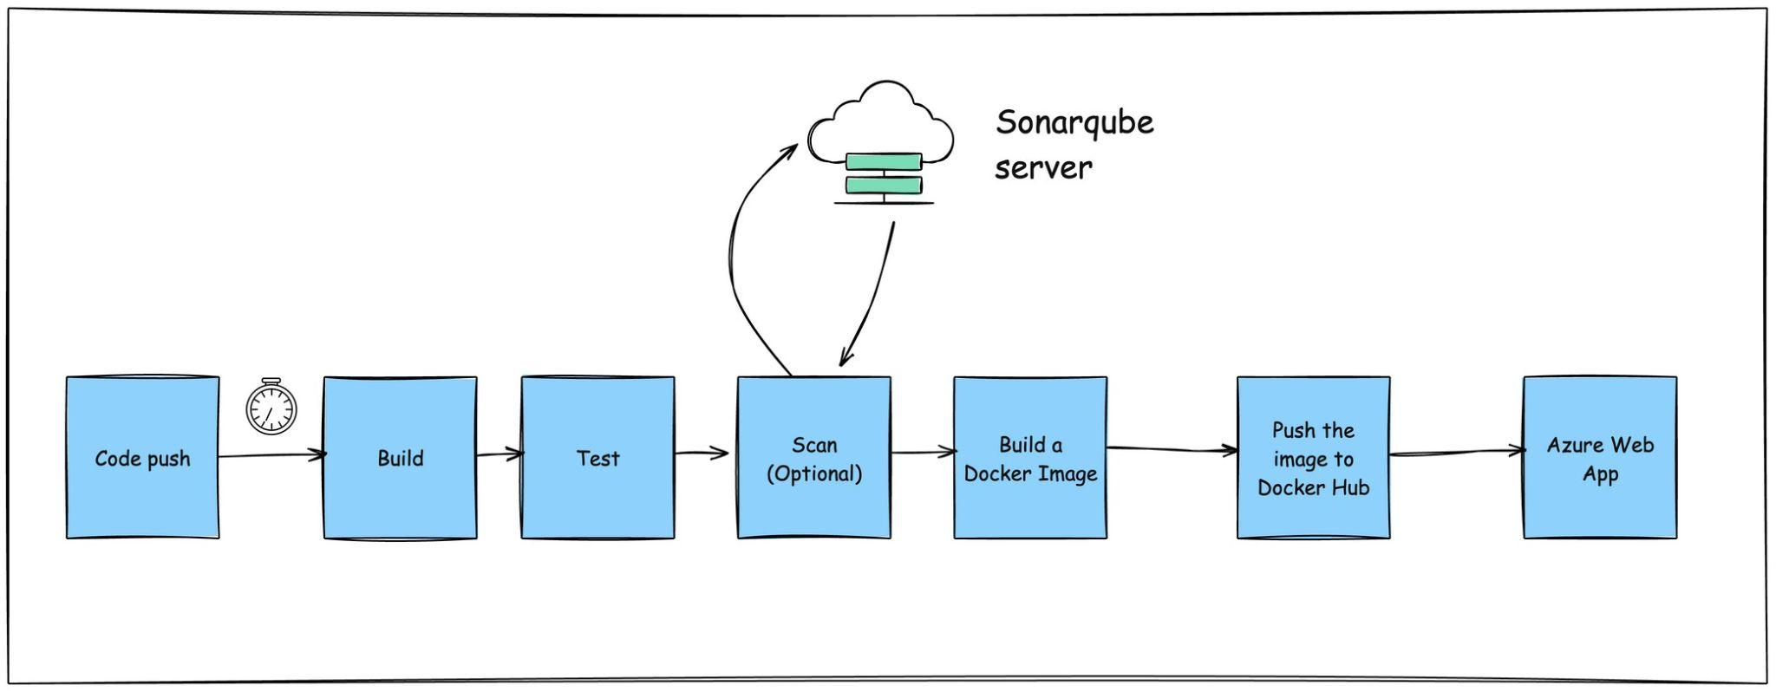

Prerequisites
- GitHub account (you can fork the sample repo).
- Azure subscription.
- Docker Hub account (repo created or permission to push).
- GitHub Secrets ready (you’ll add them below).
- An Azure Web App (Linux) configured for a container image (we’ll show a one-time setup script).

Learning objectives
- Create a GitHub Actions workflow to build, test, and deploy a Node.js app to Azure Web App (Container).
- Publish the Docker image to Docker Hub using tokens.
- Configure the Web App to pull the latest image tag per commit.
- Validate the deployment and view logs.

Before you start (one-time Azure setup)
If your App Service Plan + Web App already exist and are container-based, skip to Step 1.
Create a shell script and add the following code and execute to provision a web application
# ========= Variables (edit these) =========
RG=web-labs-rg
LOC=westeurope # pick your region
PLAN=web-labs-plan
WEBAPP=frontendapp-web
DOCKER_IMAGE=nginx:alpine # temporary image until CI/CD pushes yours
APP_PORT=3000 # your Node app's listening port
# =========================================
# Create Resource Group
az group create -n $RG -l $LOC
# Create an App Service Plan (Linux)
az appservice plan create -g $RG -n $PLAN --sku B1 --is-linux
# Create a Web App for Containers (public Docker Hub image for now)
az webapp create -g $RG -p $PLAN -n $WEBAPP \
--deployment-container-image-name $DOCKER_IMAGE
# Tell App Service which port your container exposes
az webapp config appsettings set -g $RG -n $WEBAPP \
--settings WEBSITES_PORT=$APP_PORT
# (Optional) Set a health check path for faster restarts
# az webapp update -g $RG -n $WEBAPP --set siteConfig.healthCheckPath="/healthz"
# Get the public URL
az webapp show -g $RG -n $WEBAPP --query defaultHostName -o tsv

Keep the resulting hostname handy—e.g.,
frontendapp-web.azurewebsites.net.

Step 1 — Get the code
- Fork the sample Node.js repo:
- Clone your fork locally.
If the repo doesn’t have a Dockerfile, add this one:
# 1) Build stage
FROM node:22-alpine AS build
WORKDIR /app
COPY package*.json ./
RUN npm ci
COPY . .
RUN npm run build || true
# 2) Runtime stage
FROM node:22-alpine
WORKDIR /app
ENV NODE_ENV=production
COPY --from=build /app ./
EXPOSE 3000
CMD ["npm", "start"]

Step 2 — Create GitHub Actions workflow
Create:
.github/workflows/ci.yml

You can download the workflow code from here - Pipeline Solution
Paste this workflow:
name: Build, Test, and Deploy to Azure Web App (Container)
on:
workflow_dispatch:
permissions:
contents: read
actions: read
checks: write
pull-requests: write
# Keep if you plan to switch to OIDC (federated credentials)
id-token: write
env:
APP_PORT: 3000
IMAGE_NAME: ${{ secrets.DOCKERHUB_USERNAME }}/frontendapp-node
AZURE_RESOURCE_GROUP: web-labs-rg-saurabh
AZURE_WEBAPP_NAME: frontendapp-web-saurabh
jobs:
build-test-and-deploy:
runs-on: ubuntu-latest
environment: dev
steps:
- name: Checkout code
uses: actions/checkout@v4
- name: Setup Node.js
uses: actions/setup-node@v4
with:
node-version: 22.x
cache: npm
cache-dependency-path: package-lock.json
- name: Install dependencies
run: npm ci
- name: Run unit tests (if present)
run: npm test --if-present
- name: Build (optional)
run: npm run build 2>/dev/null || echo "No build step; continuing."
- name: Azure Login (Service Principal)
# If you adopt OIDC later, drop client-secret and configure federated creds
uses: azure/login@v2
with:
client-id: ${{ secrets.AZURE_CLIENT_ID }}
tenant-id: ${{ secrets.AZURE_TENANT_ID }}
subscription-id: ${{ secrets.AZURE_SUBSCRIPTION_ID }}
client-secret: ${{ secrets.AZURE_CLIENT_SECRET }}
- name: Login to Docker Hub
uses: docker/login-action@v3
with:
username: ${{ secrets.DOCKERHUB_USERNAME }}
password: ${{ secrets.DOCKERHUB_TOKEN }}
- name: Build and push Docker image to Docker Hub
uses: docker/build-push-action@v6
with:
context: .
file: ./Dockerfile
push: true
tags: |
${{ env.IMAGE_NAME }}:${{ github.sha }}
${{ env.IMAGE_NAME }}:latest
- name: Configure Web App to use the new image
run: |
az webapp config appsettings set \
-g "${{ env.AZURE_RESOURCE_GROUP }}" \
-n "${{ env.AZURE_WEBAPP_NAME }}" \
--settings WEBSITES_PORT=${{ env.APP_PORT }} \
DOCKER_REGISTRY_SERVER_URL=https://index.docker.io/v1/
# If your Docker Hub repo is PRIVATE, also set:
# az webapp config appsettings set \
# -g "${{ env.AZURE_RESOURCE_GROUP }}" \
# -n "${{ env.AZURE_WEBAPP_NAME }}" \
# --settings DOCKER_REGISTRY_SERVER_USERNAME=${{ secrets.DOCKERHUB_USERNAME }} \
# DOCKER_REGISTRY_SERVER_PASSWORD=${{ secrets.DOCKERHUB_TOKEN }}
az webapp config container set \
-g "${{ env.AZURE_RESOURCE_GROUP }}" \
-n "${{ env.AZURE_WEBAPP_NAME }}" \
--container-image-name "${{ env.IMAGE_NAME }}:${{ github.sha }}" \
--container-registry-url "https://index.docker.io"
# Restart to pull the new image immediately
az webapp restart -g "${{ env.AZURE_RESOURCE_GROUP }}" -n "${{ env.AZURE_WEBAPP_NAME }}"

Step 3 — Add required GitHub Secrets
Azure
- AZURE_CLIENT_ID
- AZURE_TENANT_ID
- AZURE_SUBSCRIPTION_ID
- AZURE_CLIENT_SECRET
Docker Hub
- DOCKERHUB_USERNAME
- DOCKERHUB_TOKEN (create a PAT with repo write/push)
Ensure your Docker Hub repo exists (e.g., DOCKERHUB_USERNAME/frontendapp-node). Public works out of the box; for private, the action sets credentials via app settings.

Step 4 — Run the pipeline
- Commit & push .github/workflows/ci.yml.
- In Actions, run Build, Test, and Deploy to Azure Web App (Container).
Expected outcomes
- Tests (if any) pass.
- Image gets pushed to Docker Hub as
${DOCKERHUB_USERNAME}/frontendapp-node:<commit-sha> (and :latest).
- Azure Web App restarts and serves your new image.

Step 5 — Verify deployment
Get the public URL
az webapp show -g web-labs-rg -n frontendapp-web --query defaultHostName -o tsv
# Example: frontendapp-web.azurewebsites.net

Hit the app
curl https://<your-hostname>
You should see your app’s HTML/JSON or API response.
(Optional) View container logs
az webapp log tail -g web-labs-rg -n frontendapp-web

Common issues & quick fixes
Symptom | Likely cause | Fix
502 Bad Gateway / 403 | Wrong port exposed | Ensure container listens on 0.0.0.0:3000, Dockerfile EXPOSE 3000, and WEBSITES_PORT=3000.
Image pull fails | Private repo without creds | Set DOCKER_REGISTRY_SERVER_USERNAME & DOCKER_REGISTRY_SERVER_PASSWORD app settings to your Docker Hub creds.
Old version keeps serving | Web App didn’t restart | The workflow restarts; if needed, run az webapp restart again.
CrashLoop | Missing env vars / wrong start command | Verify CMD ["npm","start"], required env vars in App Settings, and health check path if configured.

